DAY 1 HOMEWORK (09/16/2026)

1.What is a programming language:
programming language is a formal system of rules, words, and symbols that allows humans to write instructions for a computer to execute.
How Programming Languages Work
- Human-Readable Code: Programmers write instructions using English-like words and mathematical symbols (called source code).
- Syntax Rules: Each language has strict grammar rules—known as syntax—that dictate how commands must be structured.
- Translation: Computers do not understand human text directly. A special program called a compiler, or interpreter translates the human-written code into binary machine code (1s and 0s) that the computer hardware can run

2.Difference between compiler v/s Interpretter
A compiler translates the entire source code into machine code all at once before running it, while an interpreter translates and executes code line by line in real time

3.Development via manual way via text file v/s using IDE

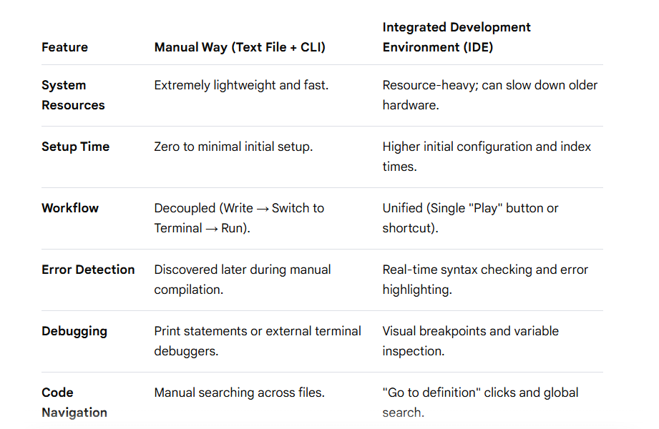

4.Difference between Syntax v/s Semantic
Syntax refers to the grammar and structural rules of a language (how words, symbols, or code are arranged), whereas semantics refers to the actual meaning or logic behind that arrangement (what the structure actually communicates or does).

5.Different Data types. Try set example
- Numeric Types (int, float, complex): Store numbers. Integers (int) represent whole numbers like 42, floats (float) represent decimals like 3.14, and complex numbers (complex) handle real and imaginary parts like 1 + 2j.
- Sequence Types (str, list, tuple, range): Store ordered collections of items. Strings (str) hold text like "Hello", lists (list) are mutable ordered sequences like [1, 2, 3], tuples (tuple) are immutable sequences like (1, 2, 3), and ranges (range) represent a sequence of numbers, often used in loops.
- Mapping Type (dict): Stores key-value pairs like {"name": "Alice", "age": 30}, allowing fast data lookup by a unique key.
- Set Types (set, frozenset): Store unordered collections of unique elements. Regular sets (set) are mutable, whereas frozen sets (frozenset) are immutable and can be used as dictionary keys.
- Boolean Type (bool): Represents truth values, either True or False, which are foundational for conditional logic and control flow.
- None Type (NoneType): Represents the absence of a value or a null value, denoted by the keyword None.

6.Difference between List, Set, Tuple
Lists are ordered and mutable collections, tuples are ordered and immutable collections, and sets are unordered collections of unique elements.

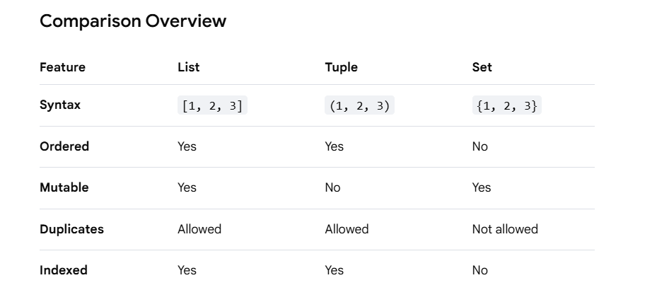
LIST:
# Creating a list of fruits
fruits_list = ["apple", "banana", "cherry", "date"]

# Accessing by positive index (First item)
print(fruits_list[0]) # Output: apple

# Accessing by negative index (Last item)
print(fruits_list[-1]) # Output: date

# Slicing (Items from index 1 up to, but not including, index 3)
print(fruits_list[1:3]) # Output: ['banana', 'cherry']

TUPLES
# Creating a tuple of coordinates
coordinates_tuple = (40.7128, -74.0060, 10.5)

# Accessing by positive index
print(coordinates_tuple[0]) # Output: 40.7128

# Accessing by negative index
print(coordinates_tuple[-2]) # Output: -74.0060

# Slicing a tuple
print(coordinates_tuple[:2]) # Output: (40.7128, -74.0060)

SET
# Creating a set of unique user IDs
user_ids_set = {101, 102, 103, 104}

# Try accessing by index (This will crash with a TypeError!)
# print(user_ids_set[0])

# Correct Way 1: Check if an item exists (Membership testing)
print(102 in user_ids_set) # Output: True
print(999 in user_ids_set) # Output: False

# Correct Way 2: Loop through the items
for user_id in user_ids_set:
print(user_id) # Output will print each ID (in unpredictable order)

